Create Your Own Dichotomous Key

Congratulations!! You are part of a collaborative scientific team that has just discovered numerous new species in the Roanoke Valley. You must now decide, within your collaborative group, how you are going to classify and name your organisms. You will need to create your own dichotomous key.

1. 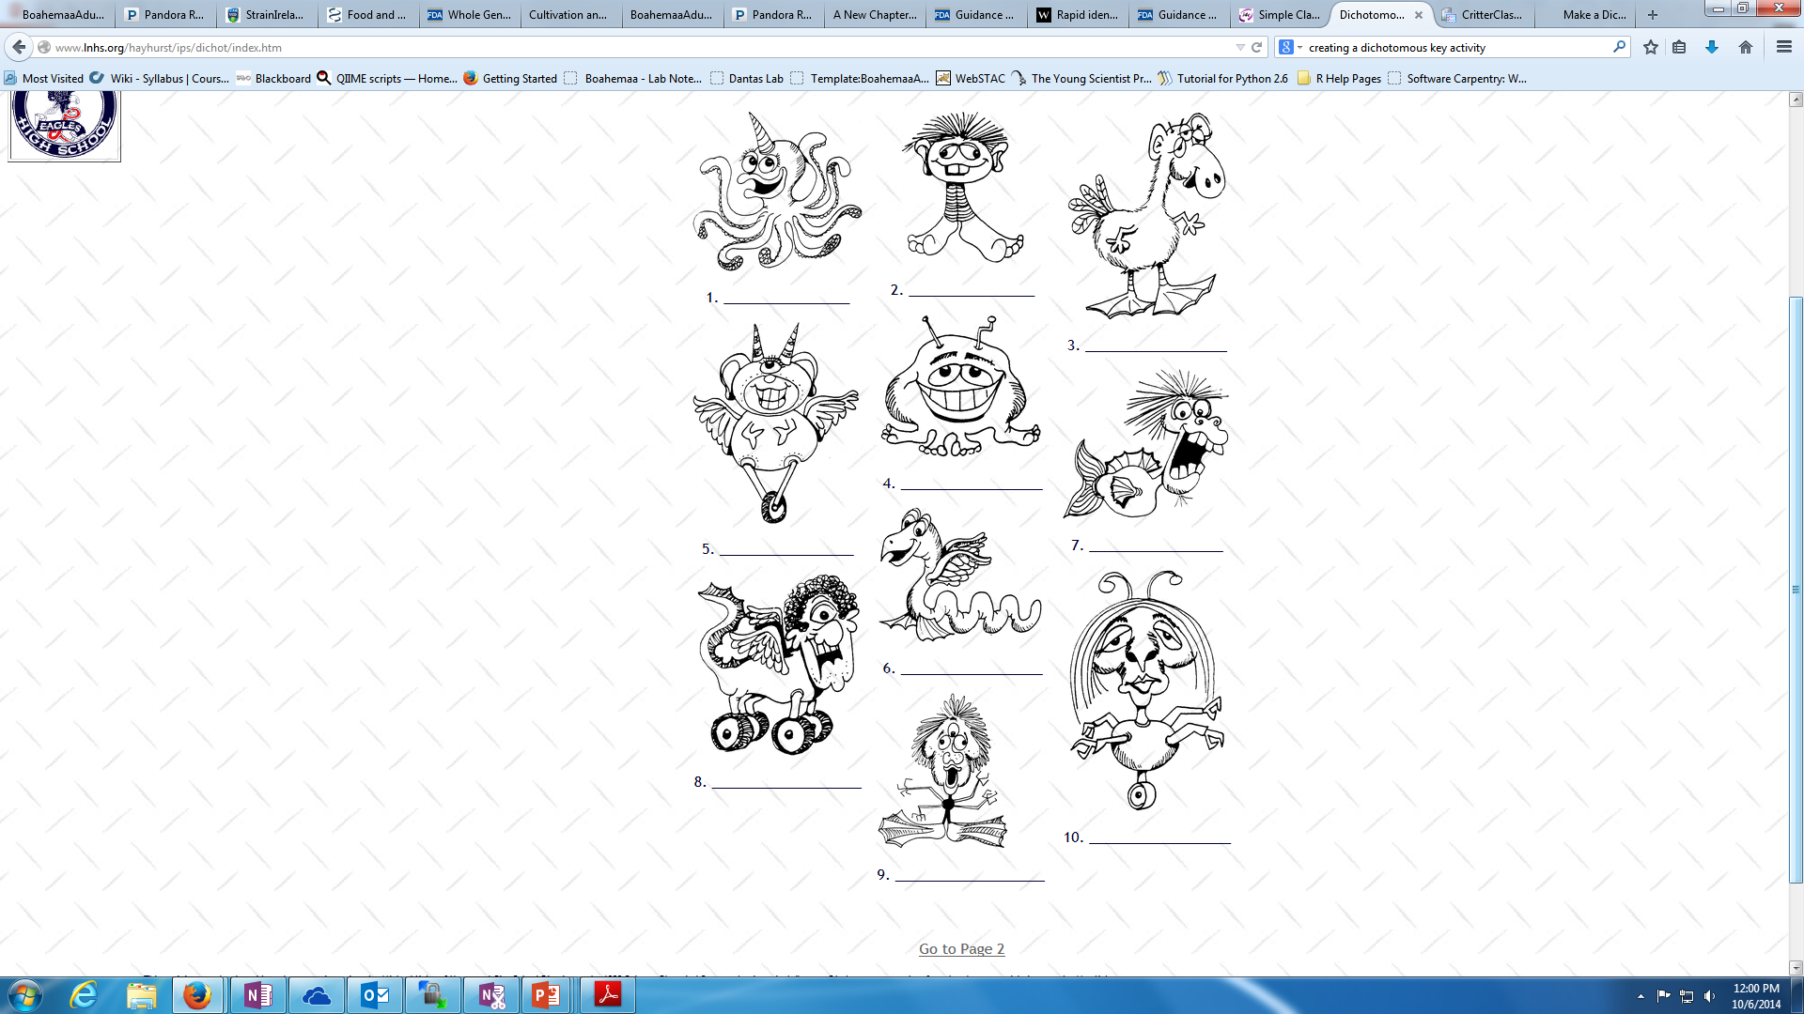Closely examine the new species. What characteristics do you think will be important in classifying these critters? Start with this one:

|  |  |
| --- | --- |
| Number of eyes |  |
|  |  |
|  |  |
|  |  |
|  |  |
|  |  |

1. Use characteristics of your choice to create your own dichotomous key. *Remember: dichotomous keys always provide 2 options at each branch!*
2. Create a key for each of the 10 species.
3. Provide a name for your critters in the space blow.
4. Throughout this exercise, what was the most difficult to do and why?
5. Do you think this would also be difficult for real-world scientists? Why or why not?

